How to Configure VS220 Sensor Modules to Report Sensor Values

Rushad Antia

In order for your sensor module to be recognized by the VR910 it needs to be properly configured. In order to do this you will need the following:

Software:

* Upload2Serial_.exe
* WirelessHARTProvisioningTool.exe

Drivers:

* Silicon Labs CP210x USB to UART Bridge Driver (CP210x_VCP_Windows.zip) (<https://www.silabs.com/Support%20Documents/Software/CP210x_VCP_Windows.zip>)
* 101-0007 MicroLink HART Modem - USB Driver Version 2.02.04 (<http://microflx.com/pages/drivers>)   
  -- Microlink HART Modem Drive (V20204_64bit)

Hardware:

* VR910 Gateway
* VS220 Sensor Module
* MicroLink HART Protocol Modem (PN: 101-0007)

# Configuring the VS220 Node

In order for the node to be recognized by the router it needs to be correctly configured.

Uploading the firmware

1. C:\Users\sensor\Downloads\windows-Logo.jpgOpen Upload2Serial_.exe and plug in the VS220 node via the USB cable.

In order to make sure that the driver has recognized the node click the key and type “Device Manager” (NOTE: You must have Administrator access to do this). Once in Device Manager go to :USER:> Ports (COM & LPT)>Silicon Labs CP210x USB to UART Bridge and find the COM number.

1. Open up the Upload2Serial_.exe and select the COM port that the VS220 node is connected to. Make sure “Packet Data Size” is left to 256 bytes and “Send Termination” is enabled. Set “Packet Retry Timeout” to 5 sec. and for “Flash Destination for Build” select AREA 4. **This step is crucial because you do not want to flash the wrong area; doing so could lead to devastating damage to the device.** **Note: For the VL10 Loop board, flash Area 2 only.**
2. Select the “Browse” button to find the Firmware file. In the case of wanting to read variables select “Upg_WHART_VS220_SimpleAPI_UART_ExtWakeup_v2_0_9a” otherwise choose the best firmware for your needs.

**Make sure the board has Jumpers J10, J12, and J21 populated while all the others are depopulated and that SW5 is set to position 2 while SW4 is set to USB.**

Before you click “Start” make sure it looks similar to this:

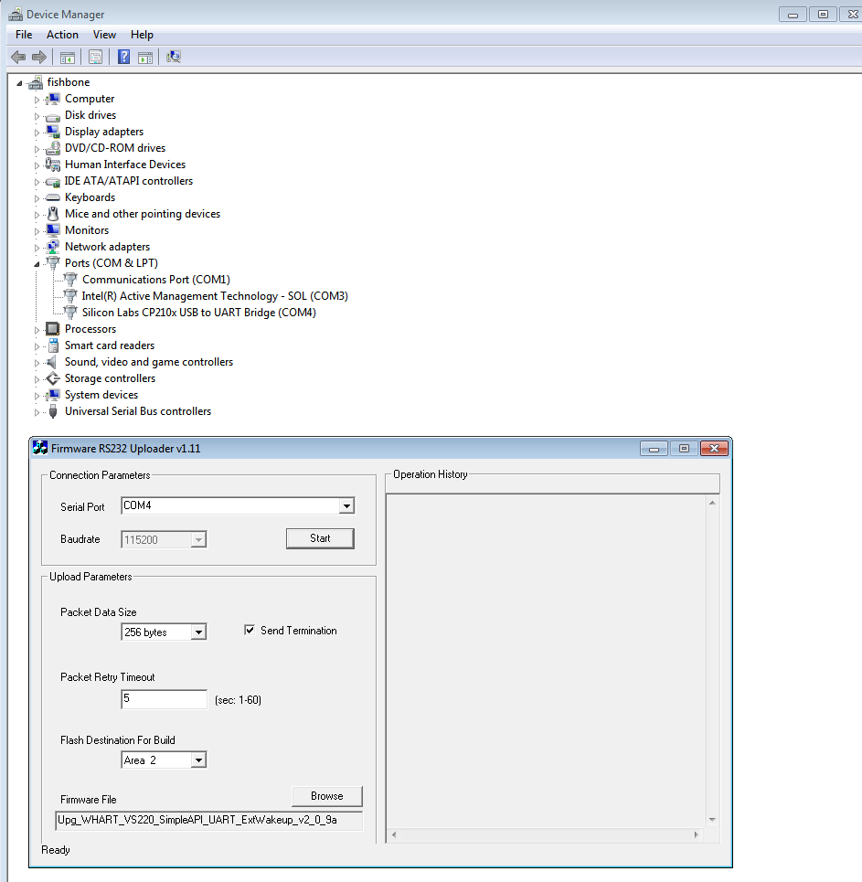

1. If it looks similar then click “Start” and make sure that you hold the “Reset” (SW1) for 1-2 seconds within 10 seconds of starting the procedure and then let go. If done correctly it should look like this:

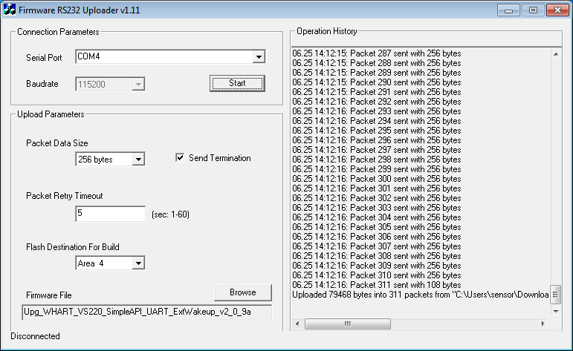

1. In order for the new firmware to take effect you need to; **Populate J12, J16 – J20, and depopulate J10, J12, and J21.** After doing this hold the reset button and reset the device.

Congratulations! You have just put the new firmware on the device! ☺

Using the WirelessHART Provisioning Tool

In order for the sensor to report its values to the VR910 Gateway it must have a burst message configured.

**\*\*\*Make sure J12 and J16-20 are populated while the rest are depopulated\*\*\***

1. While the VS220 is powered off, connect the left clip of the MicroLink HART Protocol Modem to TR2 on the board and the right clip to TR1. From the perspective of looking at the modem with the front label facing you.
2. Plug in the MicroLink HART Protocol Modem into the computer and power on the VS220 device.

Open Device Manager and go to :USER:> Ports (COM & LPT)>MicroLink HART Protocol Modem and find the COM number.

1. Open the WirelessHART Provisioning Tool and go to Settings
2. Make sure the COM port number matches that of the MicroLink HART Protocol Modem. After selected click Apply
3. Go to Device Information and click the “detect device” button. Then make sure the addresses are from [0,63] then click “Start.” After a couple seconds it should complete and look something like this:

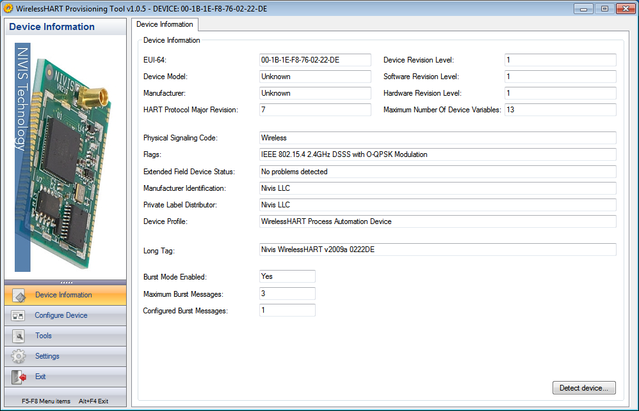

Make note of important fields such as the “EUI-64” and “Long Tag”.

1. Click on Configure device. In order to find your Network ID go to the MCS log in and click on Access Point. Locate your 4 character HEX Network ID. Now convert that HEX number into decimal and place that in the Network ID box of the WirelessHART Provisioning tool and click set. In the example below the Network ID “AAAA” translates to 43690 in decimal.

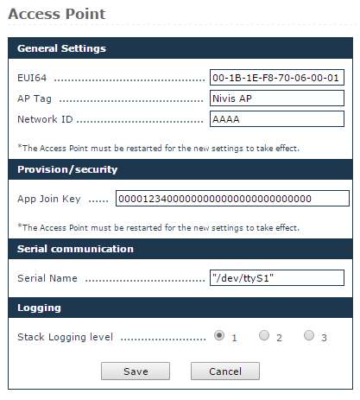

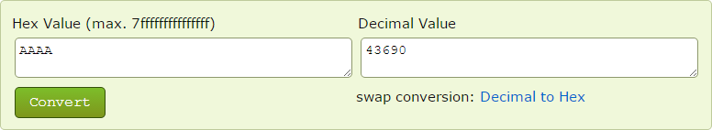

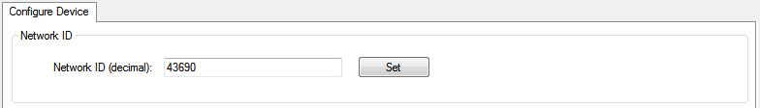

1. Enter the Join Key that can be found under the same Access Point tab in the MCS and click set. You might get a warning that Access is Denied, just ignore it and continue it will work regardless. Another problem could be that the device disconnected, if it tells you that just close the provisioning tool and redo steps 3-5.



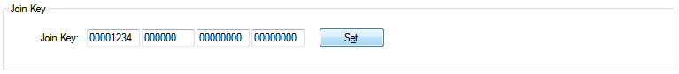

1. The next step is to configure the burst mode. So under Configure Device>Burst Information click on the modify button (for Burst Message 0). To read the sensor data configure it as shown below.

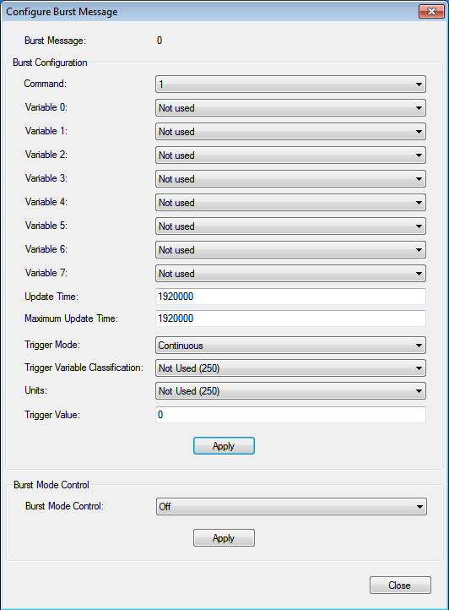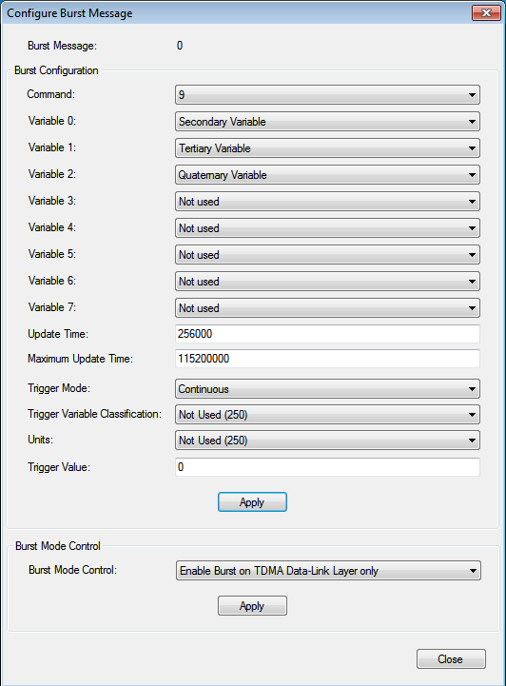 **Before After**

After all the changes click on both the apply buttons and exit the screen.

1. In order for this newly configured device to be a part of the network what you can now do is go to the Tools tab in the WirelessHART Provisioning Tool. Here you can see the “Assisted Join” button. Click it and watch each step the VS220 goes through to connect and join to the Gateway. If this seems to fail at any time don’t worry only the connection to the device has failed not the connection to the Gateway. If this happens close and reopen the WirelessHART Provisioning Tool and reconnect (detect) the device.

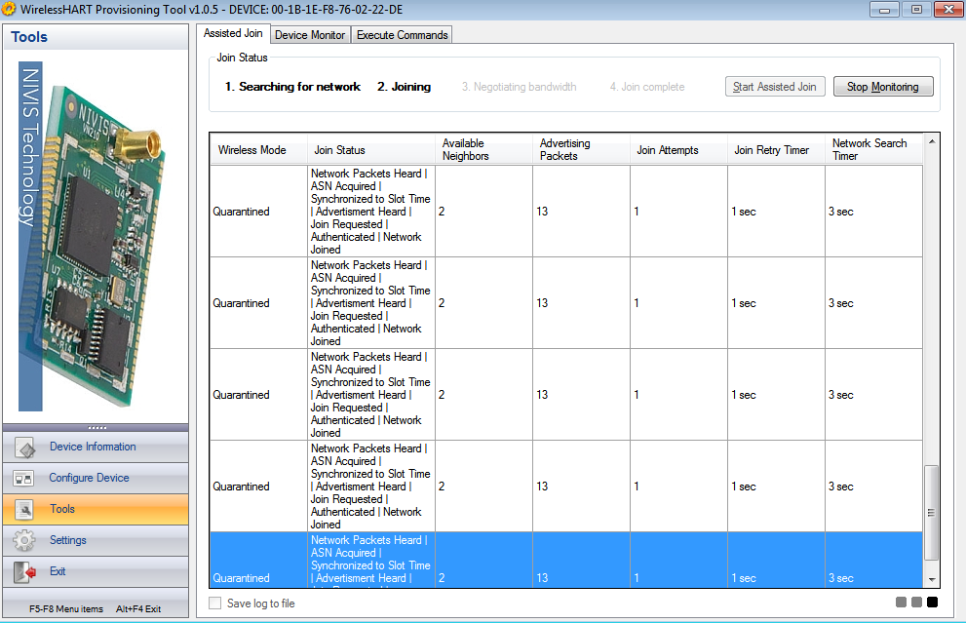

1. Now we have to configure the burst message file for the gateway to understand. Copy and paste the below text and save it as “Monitor_Host_Publishers.conf”. It is important to keep this text in the format below. Make that the file name is not saved with a .txt at the end if using Microsoft’s notepad.exe.

#[dev mac address]

#BURST=<command number>, <burst message>, <update period>, <maximum update period>

# VARIABLE=<command number>, <burst message>, <device variable code>, <name>, <device variable slot> <device variable classification>, <units code>

#TRIGGER=<command number>, <burst message>, <burst trigger mode selection>, <device variable classification>, <units code>, <trigger level>

[00-1B-1E-F8-76-02-22-DE]

BURST = 9, 0, 8, 64

VARIABLE = 9, 0, 1, Current, 0, 84, 39

VARIABLE = 9, 0, 2, Temp, 1, 64, 32

VARIABLE = 9, 0, 3, Humidity, 2, 81, 57

VARIABLE = 9, 0, 4, DewPoint, 3, 64, 32

TRIGGER = 9, 0, 0, 250, 250, 0.000000

AUTO_DETECT = DONE

BURST_NO_TOTAL_CMD_105 = 3

BURST_SET_STAT_0 = SET

BURST_SET_STAT_1 = OFF

BURST_SET_STAT_2 = OFF

# EOF

In order to add more devices just copy and paste the section above starting from the EUI-64 to the end and just change the EUI-64 to the EUI-64 of the other devices. When done save it correctly and make sure it doesn’t save as Monitor_Host_Publishers.conf.txt

1. Head to the MCS under the Monitoring Host tab. Locate where it says “Upload burst messages” and click on the “Choose File” button and select your newly made Monitor_Host_Publishers.conf file and click upload. After it says that it’s successful click on the “Activate” button. It should look like this:

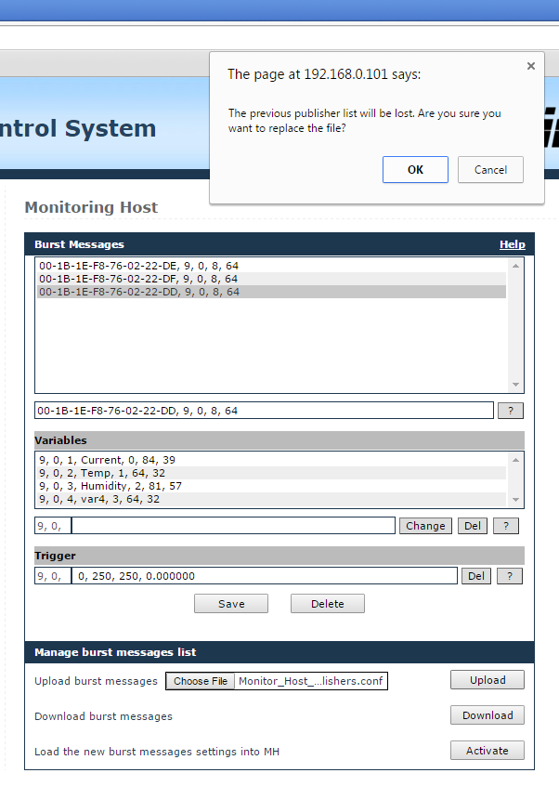

1. In a few minutes the sensors should start reporting their values into the “Readings” tab. Where they can be read.

☺☺☺ Congratulations on Configuring Your Sensors ☺☺☺